Last Updated: 05/01/2020

This guide outlines the steps required to request Time Off.

For additional information concerning Time Off policies and procedures, please refer to the Purdue Human Resources Benefits website: https://www.purdue.edu/hr/Benefits/LTD/
Note: The Time Off request feature does not replace conversations and planning between employees and supervisors.

Contents
Accessing SuccessFactors 1
Note for Employees with Multiple Appointments 1
Accessing Time Off Module / Screen Overview 2
Time Off: Requesting, Editing, and Cancelling Requests 4

Accessing SuccessFactors
Visit OneCampus and select Employee Launchpad.  Log in with username and password. | 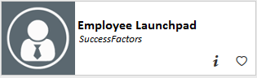

Note for Employees with Multiple Appointments
If you hold multiple positions, use the Change Selected Employment menu to select the position for which you would like to record time | 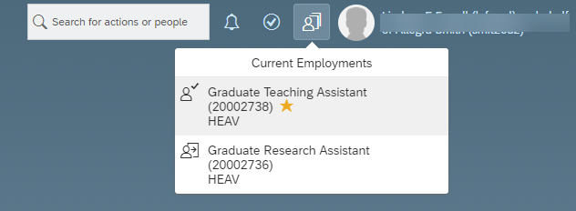
If you hold multiple positions and they are similarly named, click My Profile to validate that the correct position has been selected | 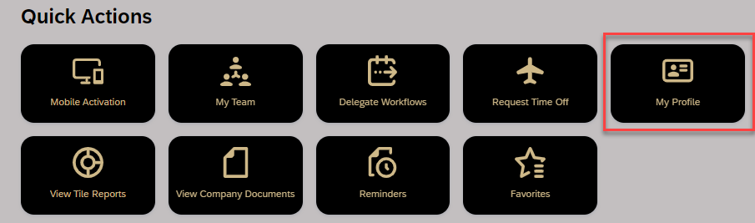
If you hold multiple positions and they are similarly named, click the Employment Information tab to view the details of the position selected in order to ensure time off is requested for the correct position.  Click the Home icon at the top of the page to return to the SuccessFactors home page. | 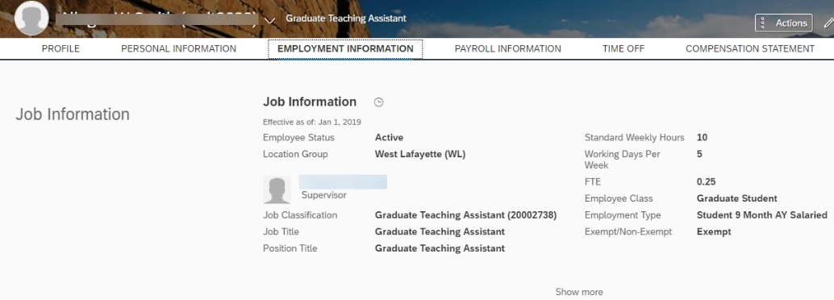

Accessing Time Off Module/Screen Overview
Select the Request Time Off Quick Action Tile. | 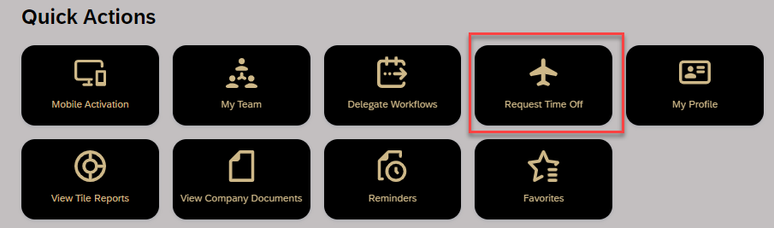
The Create Absence opens. To view calendar or Team Absences, scroll to bottom and click the Time Off link.

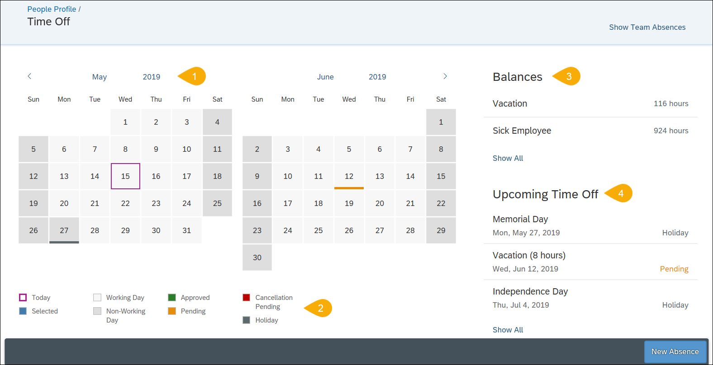

- Calendar | Displays the current and next month; dates with scheduled time off are indicated by colored bar.
- Calendar Legend | Describes each color notation that indicate various leave statuses.
- Balances | Displays Vacation and Sick Employee balances as of today’s date.
- Upcoming Time Off | Displays the next three time Absense and Holiday time off entries.

Time Off: Requesting, Editing, and Cancelling
The system will not allow you to request Time Off if you do not have, at the time that you are submitting the request, a sufficient balance (of the leave type you’ve chosen) to cover the request.

Time Off: Requesting
From the Create Absence screen:  - Select Time Off Type  - Select Time Off Date(s)  - Click Submit  If this request requires additional information or you need to see team absences, click the Time Off link at the bottom. | 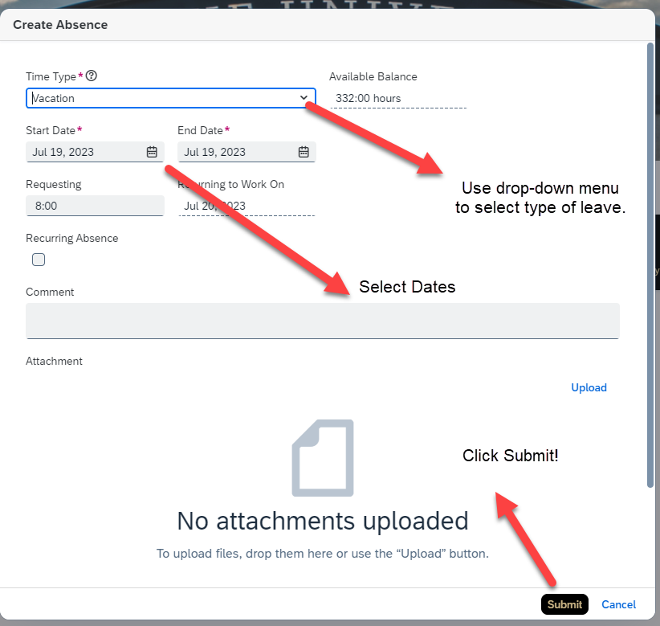  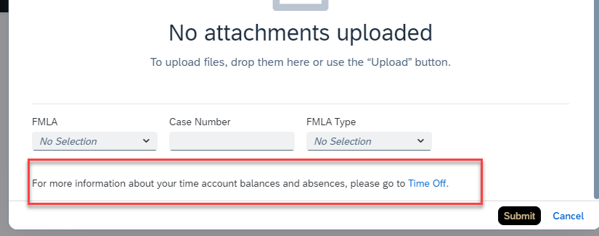
When viewing the Absence Request from the Calendar linked through Time Off, consider the following details:  - Click on the Time Type dro-down to select the desired leave type.  - Enter or select from the calendar the Start and End Date for the leave request.  - If requesting recurring time off over several days – move to the next step.  Enter the number of hours for the leave. | 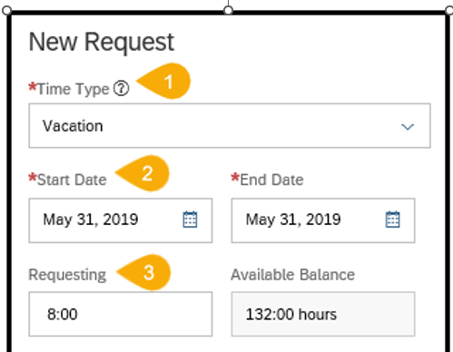
- Enter the number of hours for the leave in the Requesting field.  - Employees who do not clock in and out daily will request partial time off in hours and tenths.  - Example: Seth would like to request vacation for half a day on Wednesday and all of Thursday and Friday. Seth must submit one request for the Wednesday half day and another for the full days, Thursday and Friday.  - Employees who do clock in and out daily will request partial time off using exact hours in military time.  - Employees who utilize Positive Duration or Webclock time entry are encouraged to wait until they have recorded their working time for the day on which they plan to request partial Time Off before submitting their Time Off request. This will avoid errors and need to re-submit requests if the amount of working time is more or less than expected.  - Enter any information you would like to provide to your supervisor in the Comments text entry box.  - Click the + (Plus Sign) to upload and attach any supporting documentation (Example: Jury Duty summons, Military orders)  - Select YES in the FMLA drop-down field to request FMLA and provide the Case Number provided by Human Resources – Benefits.  - Access the Family and Medical Leave Act (FMLA) forms via the Human Resources “ Forms ” web page, “Benefits” tab. The “Request and Notice ” and “ Medical Certification ” forms are required to be completed and returned before FMLA leaves can be approved.  Click Submit to submit request to supervisor for approval.  Click Cancel to clear all fields; request does not move forward. | 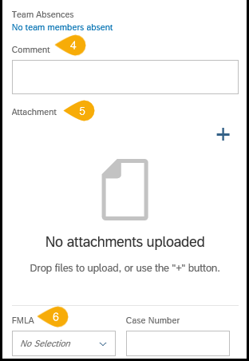  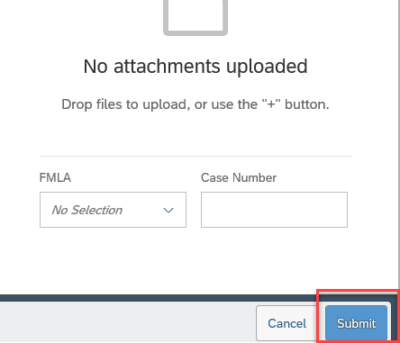
Recurring Absence  Recurring Absence is used when needing to take partial days or a specific increment of hours over several days.  - Click to check the Recurring Absence box.  - Select daily, weekly or biweekly from the Recurs drop-down.  - Validate the Requesting hours is correct (the system defaults to 8 hours.)  - Type or select the date the leave Ends on. | 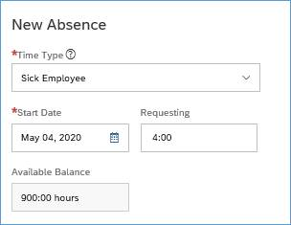  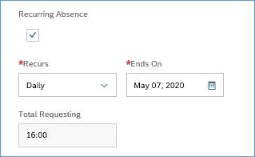
After submitting, the request is listed under the Upcoming Time Off heading with a status of Pending.  The employee’s supervisor receives an email notification that a request has been submitted.  The request is also now indicated as Pending with a gold line on the date on the Calendar. | 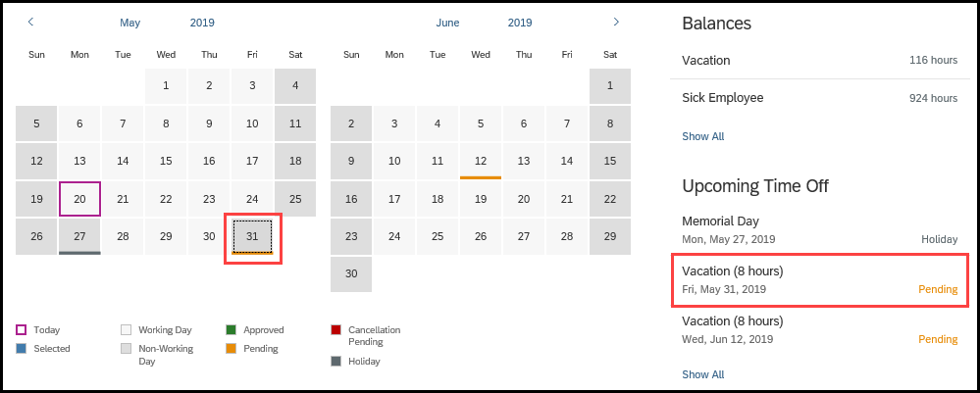
Once a leave has been approved, the status will change from Pending to Approved. | 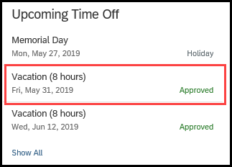
Comments added by the employee or approver can be viewed by clicking the desired request under the Upcoming Time Off heading. | 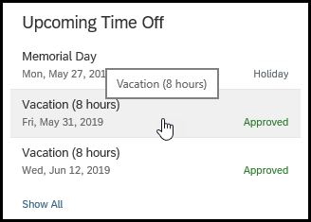
The Request Details opens and all Comments are displayed. | 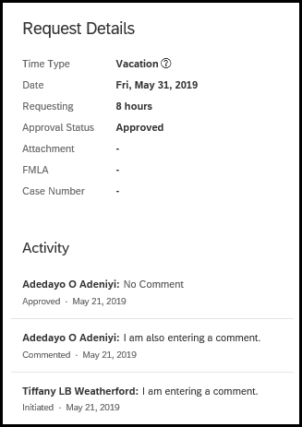

Time Off: Editing
The submitted request can be accessed by clicking the Date on the Calendar, or by clicking the Absence listed under the Upcoming Time Off heading. | 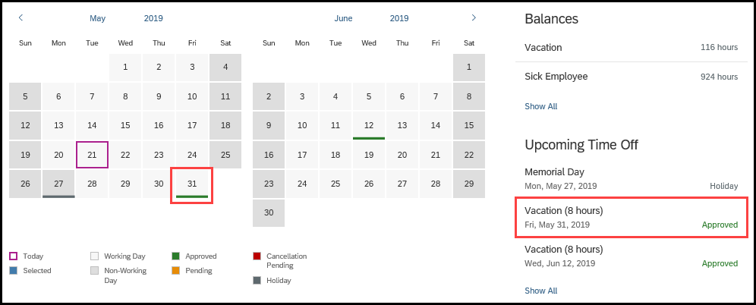
If using the Calendar, click the Pencil icon to edit. | 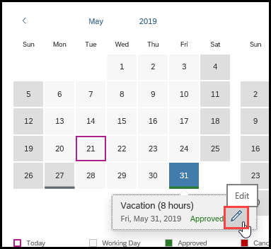
If accessing through Upcoming Time Off, click Edit Absence. | 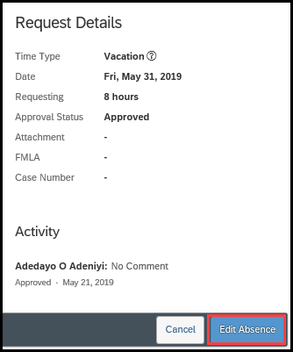
Make necessary edits to the request.  Click Submit.  NOTE: The edited request will be routed for approval only if the original request was already approved. | 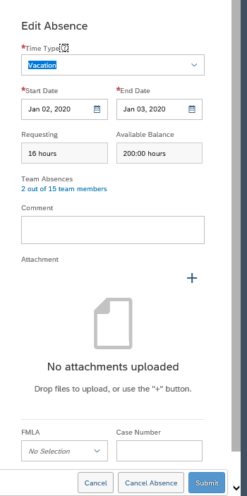

Time Off: Cancelling
The submitted request can be accessed by clicking the Date on the Calendar, or by clicking the Absence listed under the Upcoming Time Off heading.
If using the Calendar, click the Pencil icon to edit.
If accessing through Upcoming Time Off, click Edit Absence.  Click Cancel Request.  NOTE: The cancelled request will be routed for approval only if the original request was already approved. | 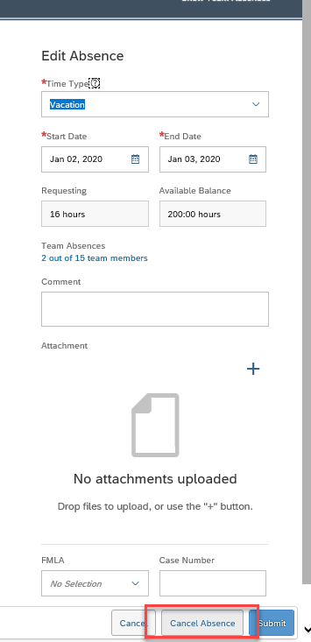
Click Yes to confirm cancellation.  Click No to exit from the cancellation request without submitting. | 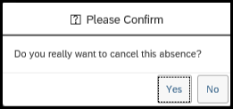

Calendar
The calendar displays Pending, Approved, and Cancellation Pending leave requests for the current and next month. | 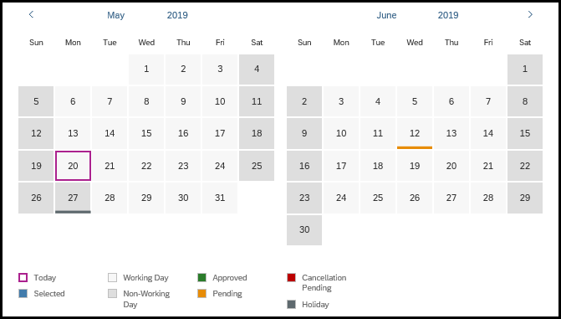

Balance Overview
Vacation and Sick Employee balances as of today’s date are listed under the Balances heading on the top right of the screen.  Click Show All to view more leave types. | 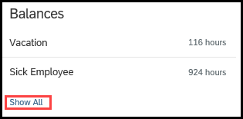
The appropriate leave types based on your employee class will be displayed. | 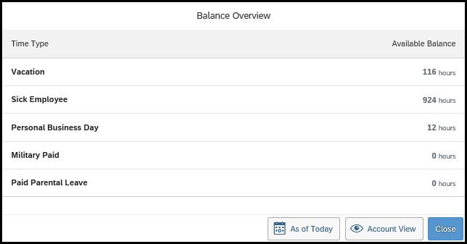
To view leave balances as of a future date, click the As of Today button. | 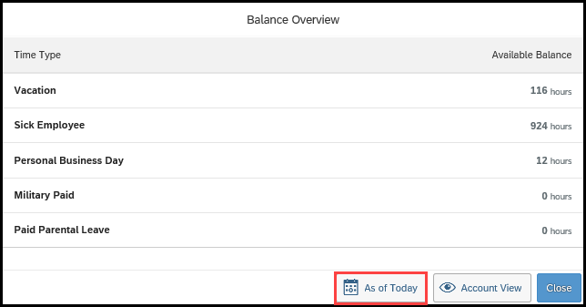
Select a date past any future approved leaves to view your “true” balances (less any future takings).  NOTE: Moving the date will not add to the balances due to projected accruals. | 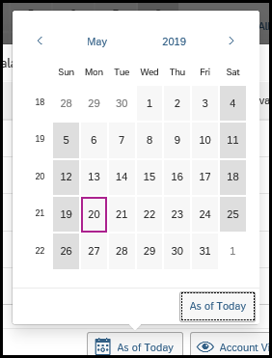
To view additional balance details, click Account View. | 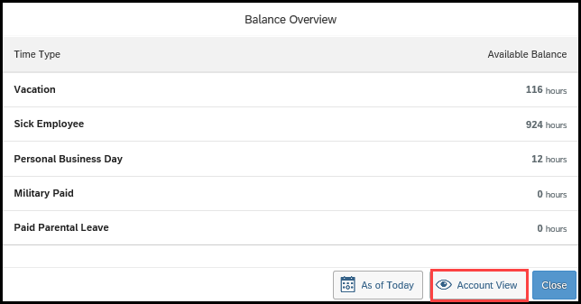
Time off balances are displayed with Earned, Taken, Planned, and Available. | 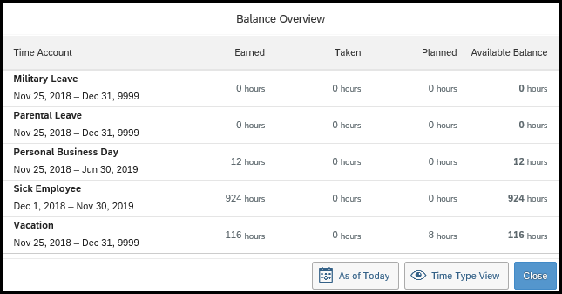

Upcoming Time Off
Holidays and Pending or Approved absences are listed under the Upcoming Time Off heading.  Click Show All to view a complete list. | 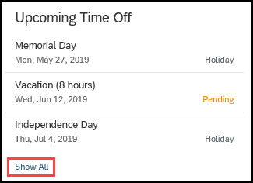
A list of Absences and Holidays is displayed. | 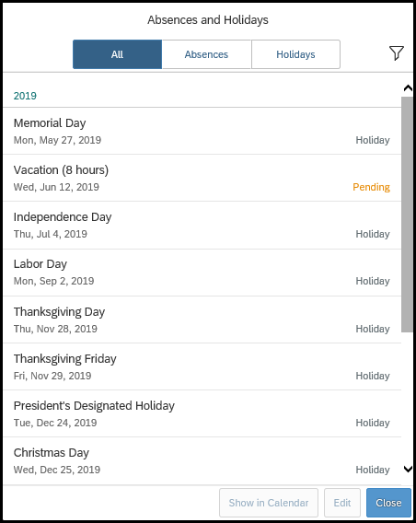
Using the tabs, the view can be changed from displaying only Absences or only Holidays.  The Filter can be used to filter by Future Events or Past Events. | 